VISVESVARAYA TECHNOLOGICAL UNIVERSITY
Jnana Sangama, Belgavi – 590018.

Report on

“Design a DFA for given language using JFLAP software”
Submitted in partial fulfillment of the requirements of the award of degree of

BACHELOR OF ENGINEERING IN
ARTIFICIAL INTELLIGENCE AND DATA SCIENCE
Submitted By:

SUPRIYA V 1SJ22AD049

UNDER THE GUIDANCE OF

SANDHYA R ASSISTANT PROFESSOR
DEPARTMENT OF ARTIFICIAL INTELLIGENCE AND DATA SCIENCE, SJCIT



SJC INSTITUTE OF TECHNOLOGY
DEPARTMENT OF ARTIFICIAL INTELLIGENCE AND DATA SCIENCE, CHICKBALLAPUR-562101
2024-2025

Introduction
JFLAP (Java Formal Languages and Automata Package) is an interactive software tool designed to help students and researchers explore concepts in formal languages, automata theory, and computational theory. It provides a graphical interface for experimenting with various computational models such as:

- Finite Automata (Deterministic and Nondeterministic)
- Context-Free Grammars (CFGs)
- Pushdown Automata (PDA)
- Turing Machines
- Regular Expressions

Key Features:

- Visualization: JFLAP allows users to create and visualize automata, grammars, and machines, which aids in understanding the behaviour of these formal systems.
- Simulations: It can simulate the operation of automata on input strings, making it easier to understand how a machine processes data.
- Conversion Tools: JFLAP includes tools for converting between different representations (e.g., from regular expressions to finite automata, or vice versa).
- Learning Aid: It is widely used in educational settings to teach theory of computation and formal languages.

JFLAP is a helpful tool for anyone studying automata theory, as it provides an interactive, visual environment to experiment and test concepts that can be abstract and difficult to grasp through theory alone.

Official Website of JFlap - https://www.jflap.org/

Steps to install JFLAP
- Visit the website https://www.jflap.org/
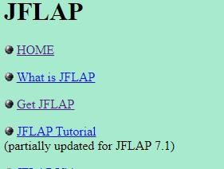

- Press Get JFLAP
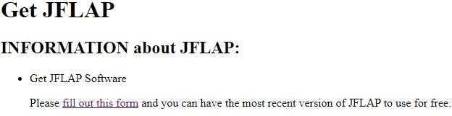

- Fill the form

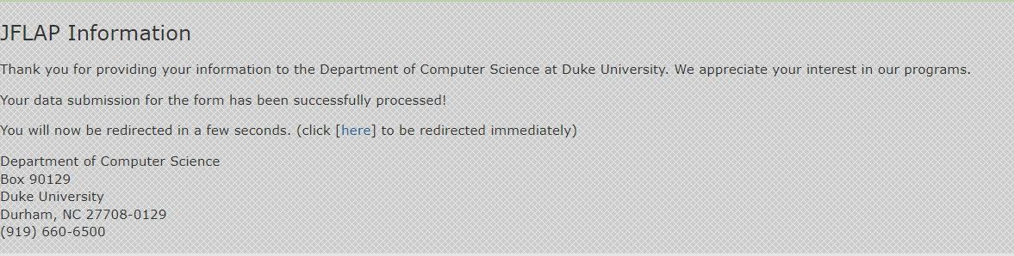
- After filling the form press Submit.

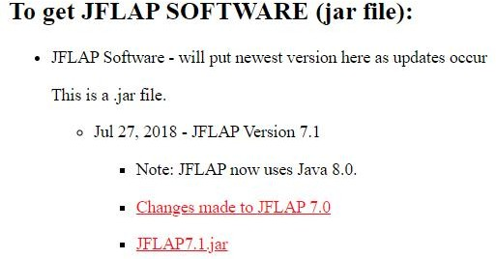
- Press the following link to download the ‘.jar’ file.

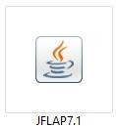

- Pre-requisite of running JFLAP is installations of JDK.

- After successfully downloading the file. Locate the file.

Now open the file by double-clicking the file.
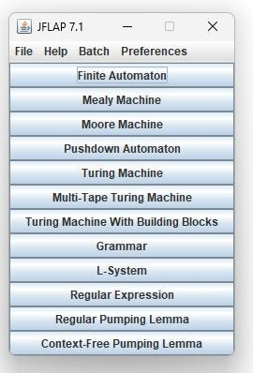

This popup will appear, now select the appropriate application and proceed.

Understanding Automata Editor

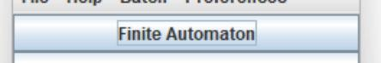

After selecting this Finite automata, the following window will open, this window contains multiple options, which directly or indirectly are very useful.

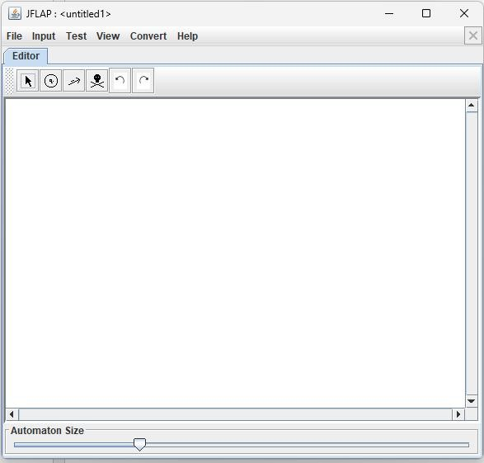

The menu contains 6 options, which further contain sub-menu.


The Input option contains some very important set of functions, which will be used in the future implementation.
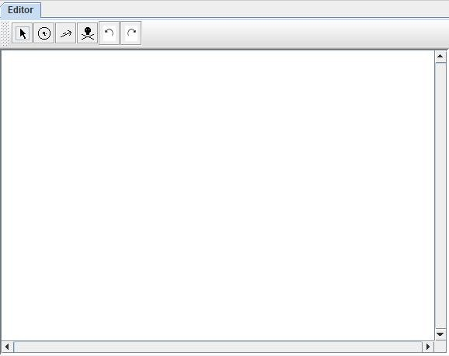

The above is the editing module, where the actual FA (Finite Automata) can be designed. The editor module has 6 options,
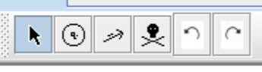
Option 1- Arrow key:
This function is used for adjusting and relocating the already existing states i.e. drag
and drop.

Option 2 - State selector:
This function is used for creating states, using the left click on the mouse the states can be put on the editor section.

Option 3 – Transition Creator:
This option can be utilized to connect two states by creating a state transition with any
symbol.

Option 4 – Delete:
This function can be utilized to delete any state or transition.

Option 5&6 – Undo and Redo.

Simulating an Automata

Example: Construct a DFA for a string of a’s and b’s containing the substring ‘ab’. The above is the constructed DFA for the given question.

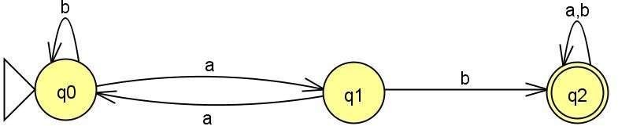

Now, let’s test the DFA with a string to check whether it satisfies the given condition of substring ‘ab’.

To test the substring, go to the ‘input’ option in the drop-down menu tabs.


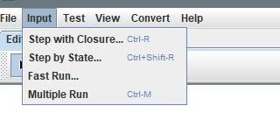
Then select ‘Step by State’ option,

After selecting that option,
you’ll get a pop to enter a string, just like the one in the bellow image.
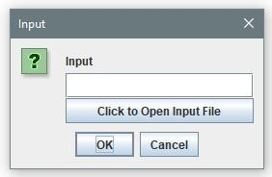
Now enter the string to be checked in the dialog box in the pop-up.
Then press ‘Click to open input File’, bellow is the input string to test the given DFA.
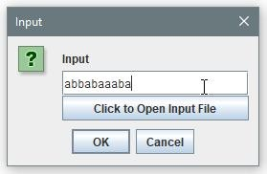
After this step, you’ll be redirected back to the editor tab, and another new tab will open by the title ‘Simulate:<your_string>’
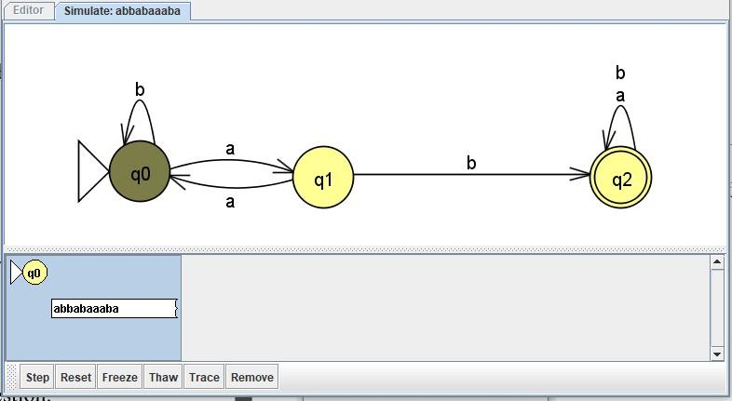

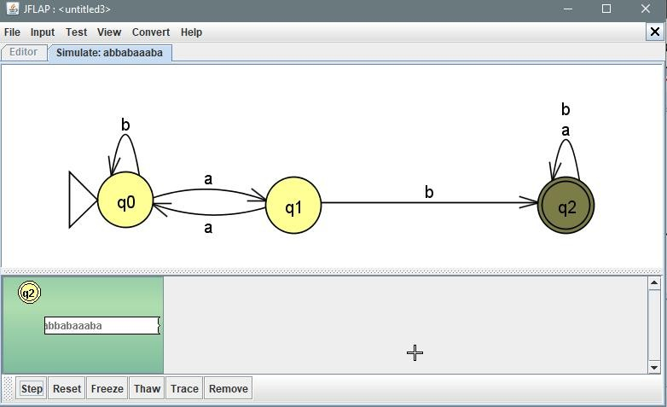
In the left bottom most corner the option ‘step’ is avalible, using that option will be studying the moment of state transition of string on the constructed DFA.

After press ‘step’ at the last most symbol of the string, if the box turns ‘green’, it means the string is satisfied with the constructed DFA.
If the box turns ‘red’, like the image down, it means the string failed to match the DFA.
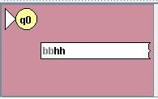

We have successfully simulated a DFA on JFLap, an opensource java-based tool.

“Conversion of Regular Expression to Finite Automata”

Create a New Regular Expression:
From the main menu, go to File > New and select "Regular Expression".

Enter the Regular Expression:
In the Regular Expression window, type or paste your regular expression in the text box. For example, for a regular expression like a(b|c)*d, simply type it in.

Convert the Regular Expression to an NFA (Non-deterministic Finite Automaton):
After entering the regular expression, click on the Convert button (or go to the menu Convert > To NFA).
JFLAP will automatically convert your regular expression into a Non-deterministic Finite Automaton (NFA).

View the NFA:
The NFA will appear on the screen, with states and transitions representing the regular expression.
You can interact with the NFA by clicking and dragging states, or by selecting specific transitions.

Save and Export:
Save your work using the File > Save As option. Files are saved with .jff extension. Export diagrams or results for reports or presentations as images or text.

Use Advanced Features:
For more complex tasks, such as:
Minimization of DFA
Grammar parsing and ambiguity checking Multi-tape Turing Machines Feel free to ask if you need specific examples or guidance on using JFLAP.

To convert the regular expression (a+b)∗abb into a finite automaton (FA), we'll break it down into smaller parts and then combine them. Here's how we can approach it:

Regular Expression: (a+b)∗abb
- (a+b)∗: This part matches any sequence of as and bs, including the empty string.
- abb: This part matches the exact sequence "abb" at the end.

Step-by-Step Construction of the Finite Automaton
We will construct a Nondeterministic Finite Automaton (NFA) that recognizes (a+b)∗abb, as an NFA is simpler to create for regular expressions with repetition (like (a+b)∗).

States:
  - q0: The start state, which can loop on any sequence of as or bs, or move toward

recognizing the sequence abb.
  - q1: This state is reached after reading the first a of abb.
  - q2: This state is reached after reading the first b of abb.
  - q3: This is the accepting state, which is reached after reading the second b of abb.

Alphabet:
The alphabet is Σ={a,b}

Transitions:
- From q0 (the start state):
  - On input a, stay in q0 (since (a+b)∗ can match any sequence of as and bs).
  - On input b, stay in q0 (same reason as above).
  - On input a, transition to q1 (start matching "abb").
- From q1 (after reading the first a of "abb"):
  - On input a, stay in q1 (any sequence of as can precede "abb").
  - On input b, transition to q2 (read the first b of "abb").
- From q2 (after reading the first b of "abb"):
  - On input a, return to q0 (any a resets the matching process).
  - On input b, transition to q3 (read the second b of "abb").
- From q3 (after reading the second b of "abb"):
  - On input a, stay in q0 (we can continue matching additional as and bs).
  - On input b, stay in q0 (same reason as above).

Accepting States:
- q3 is the accepting state because this is the state reached when the automaton has successfully matched the sequence "abb" at the end of the string.

Final NFA Description:
- States: Q={q0,q1,q2,q3}
- Alphabet: Σ={a,b}
- Start state: q0
- Accept state: q3
- Transitions:

Current State Input a Input b

q0 | q0 | q0
q0 | q1 | -
q1 | q1 | q2
q2 | q0 | q3
q3 | q0 | q0
Diagram of the NFA
Here’s the diagram for the NFA: a,b
+ +
| |
v |
(q0) ---- a ----> (q1) ---- b ----> (q2) ---- b > (q3)
| | | |
+ + + + +
a,b a,b a,b

Explanation:
- q0 is the initial state. From q0, we can loop on any sequence of as and bs. This accounts for (a+b)∗, which allows any combination of as and bs.
- When we encounter the first a, we transition to q1 (starting the sequence "abb").
- After reading the first b, we move to q2.
- After reading the second b, we reach q3, the accepting state, because we’ve matched the sequence "abb".
- From q3, we can continue reading any as or bs and the automaton will remain in q0. Final Notes:
- This is an NFA because it has non-deterministic transitions where the automaton can

stay in q0 or transition to other states when reading a or b.
- The automaton accepts any string that ends with "abb" and allows arbitrary sequences of as and bs before it.
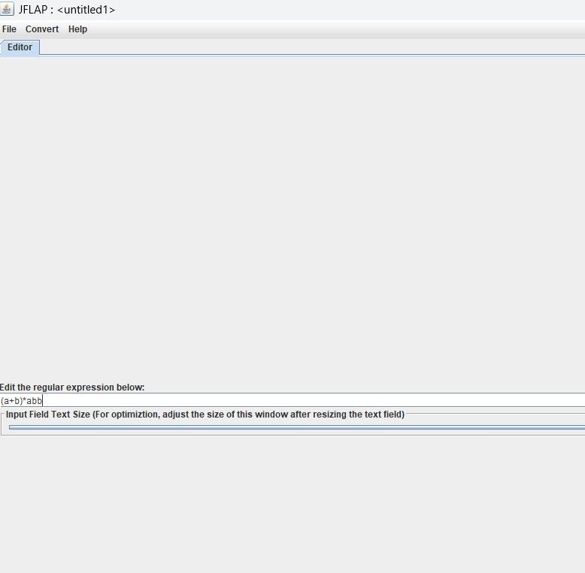
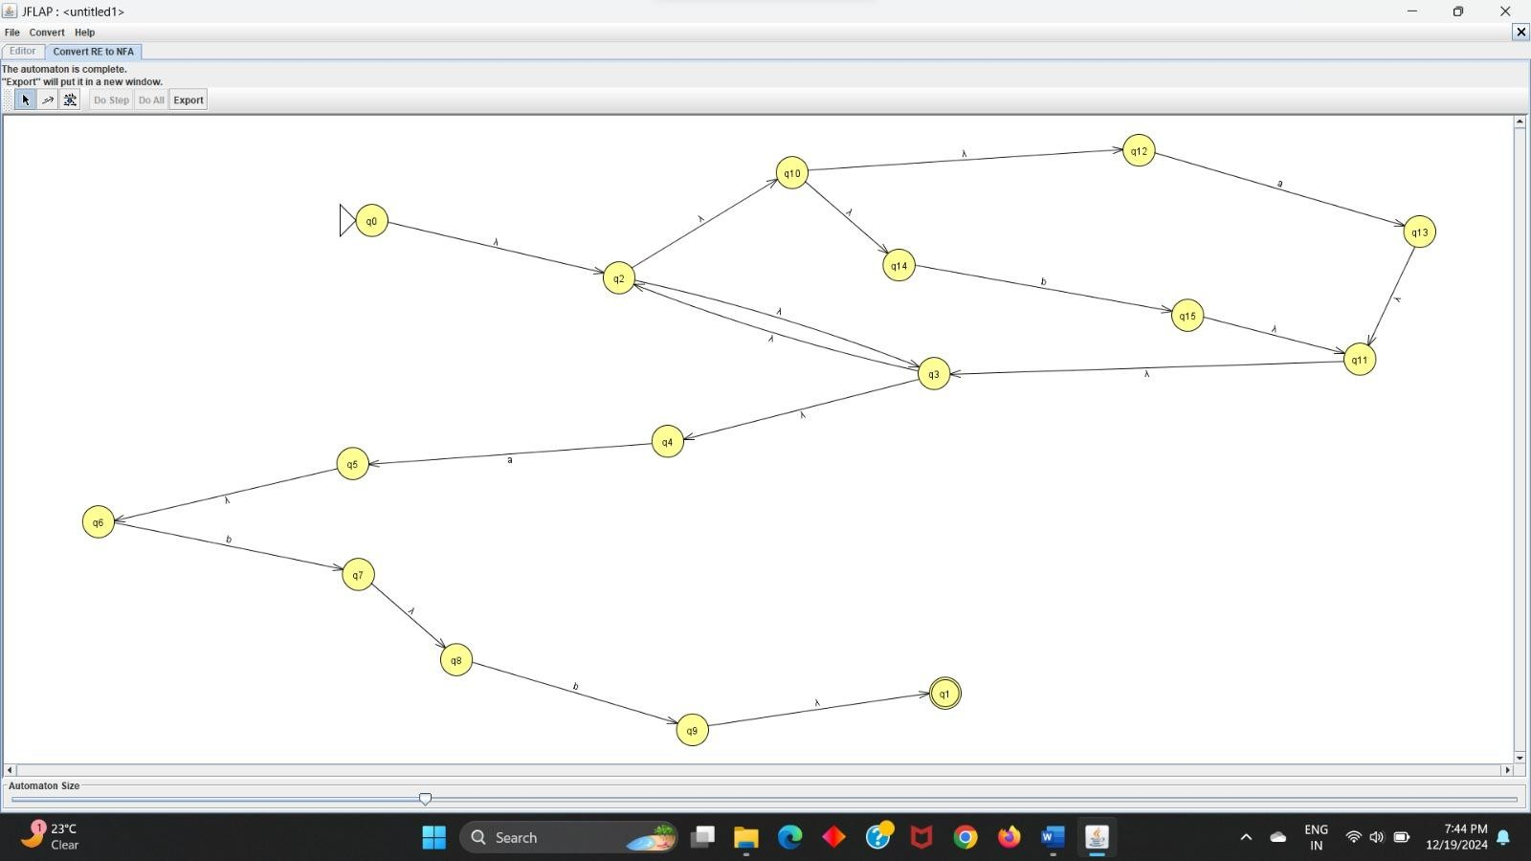
This NFA matches the regular expression (a+b)∗abb.

We have successfully simulated a Regular Expression on JFLap, an opensource java-based tool.

